1. Defence in Depth

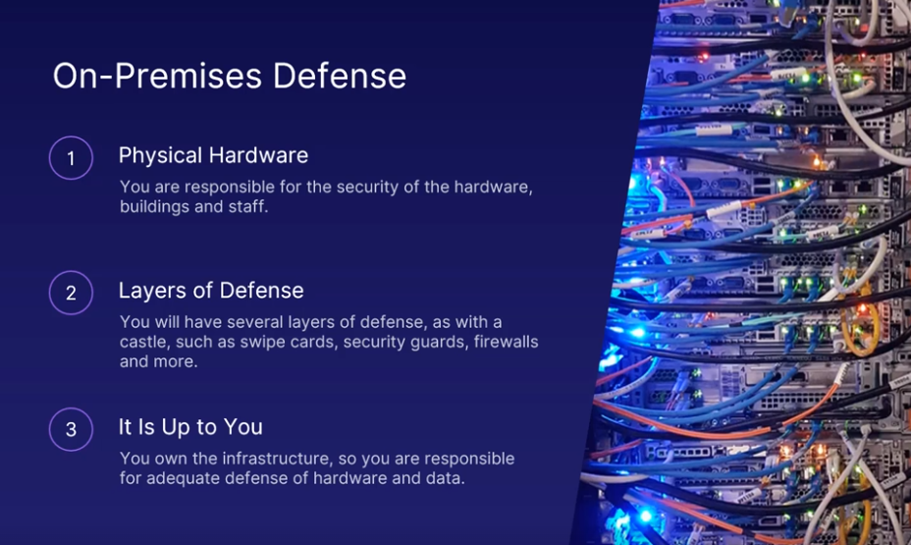



Provides security to your Azure applications

Relates to the Azure Active Directory, which controls all access to Azure and the identity of all users, applications, and connections.

Is the protection against DDoS attacks, volumetric attacks, protocol attacks, and more

Protects against intruders trying to get into your virtual machines or databases.

Is the filter of traffic to and from Azure using virtual networks and applying security standards.

applying security standards.

This is the actual Data centre. Only authorized personnel has access.

Security Network Connectivity

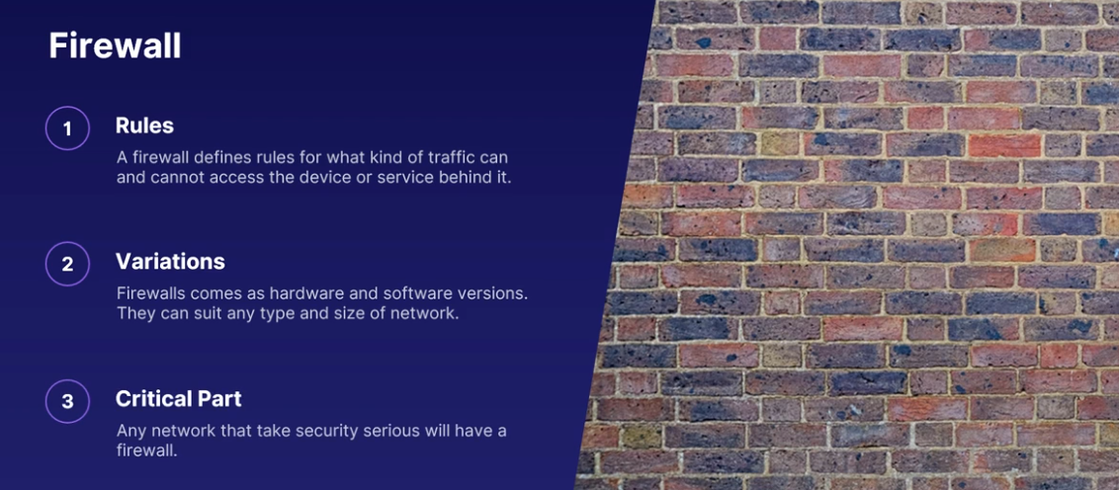

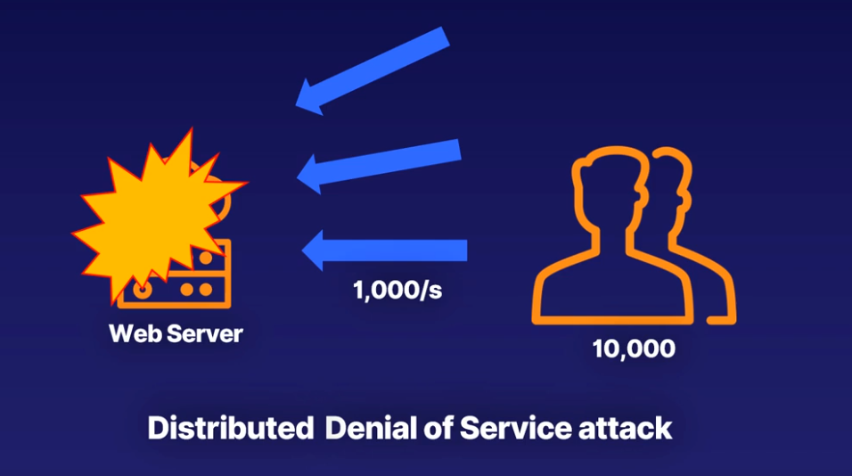

DDoS attack is lots of computers targeting a single server or website with the aim of making it stop.

A famous DDoS attack was, as I said before, against the developer website GitHub in 2018, where attackers sent 127 million requests per second.

To protect against DDoS, Azure has the DDoS Protection service. This service has various levels of protection, depending on what your needs are for your application.

At its core, Azure detects the DDoS attack and deflects it away from your service. And this is done without any interruption to your application due to Azure's global presence.

Network Security Groups (NSG): There are network security groups. Think of these as personal firewalls for your resources. You can attach an NSG to any virtual network, subnet, or network interface, Which is attached to a virtual machine. A network security group, often called NSG, is a set of rules for who and what can access any resource attached to the NSG.

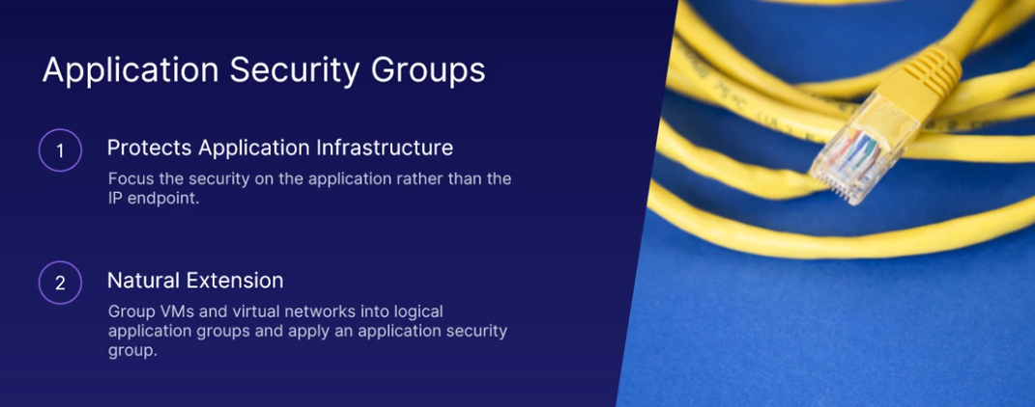

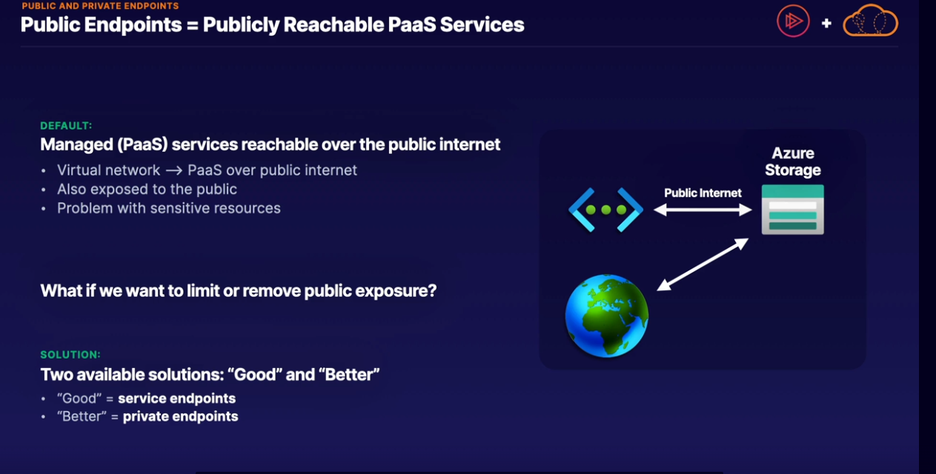

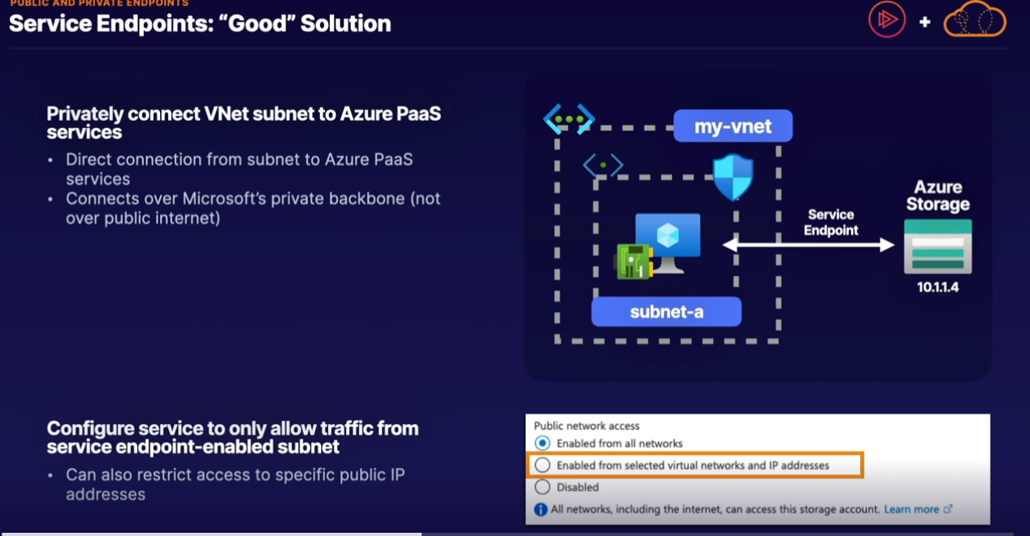

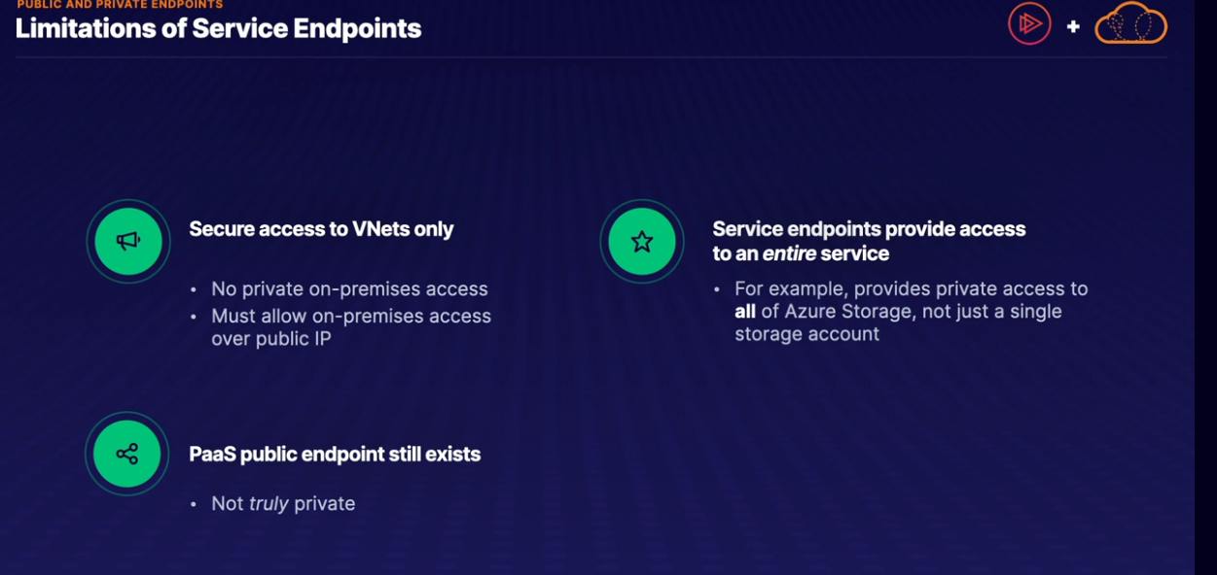

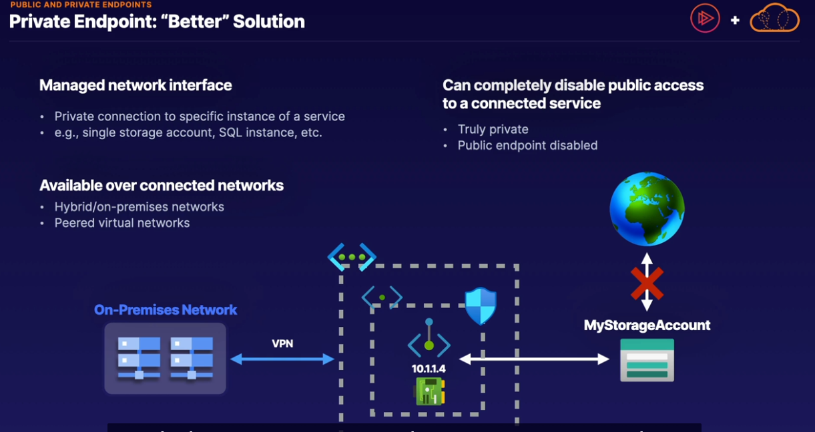

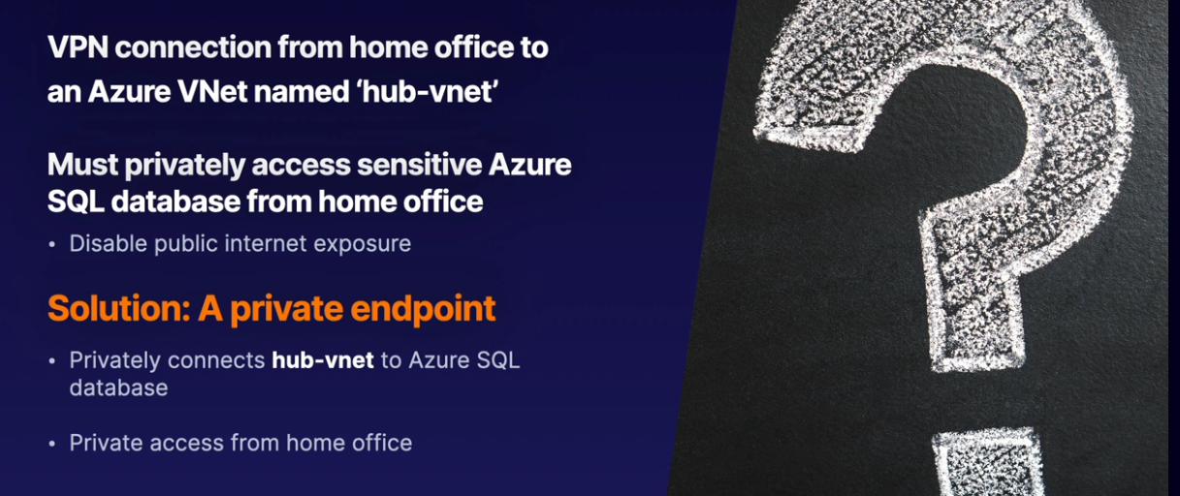

Microsoft Defender for Cloud

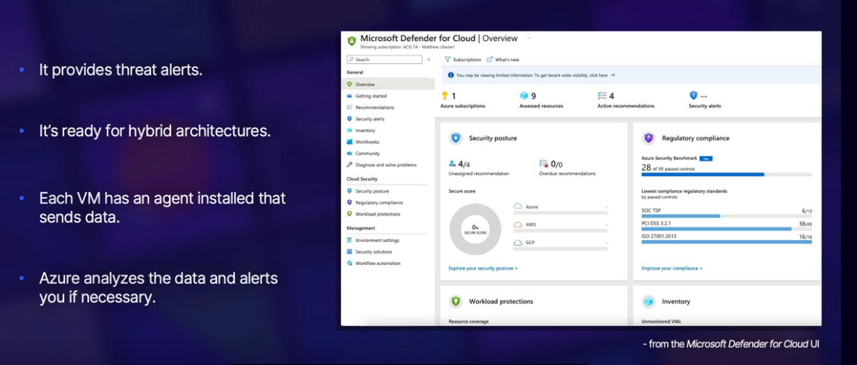

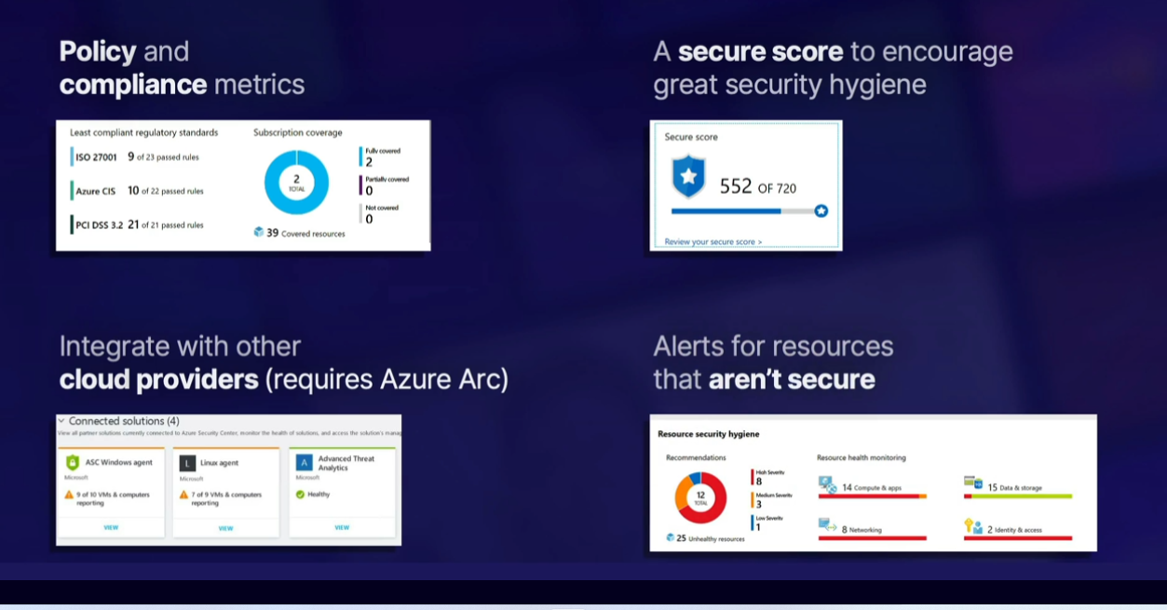

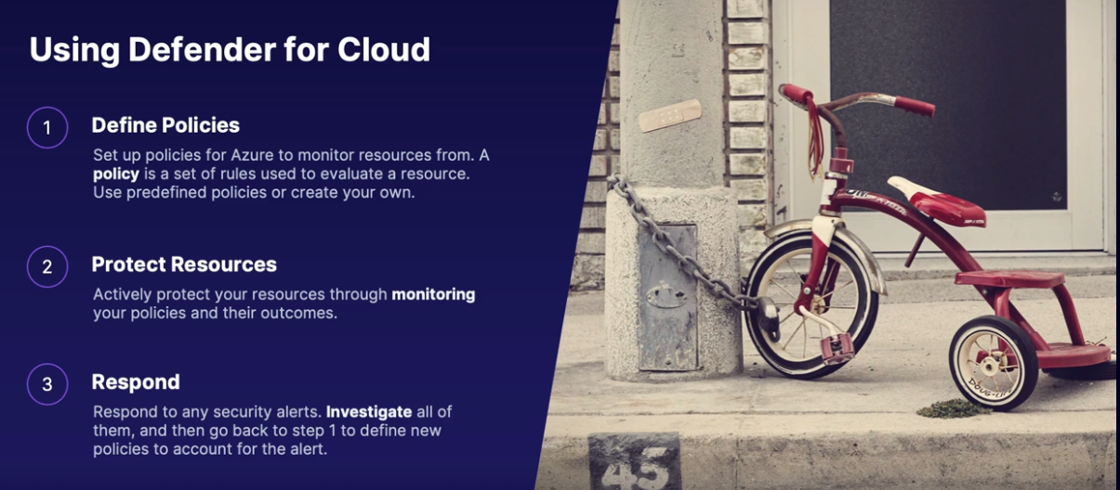

Key Vault

Azure Key Vault is a secure place to store passwords and other secrets.

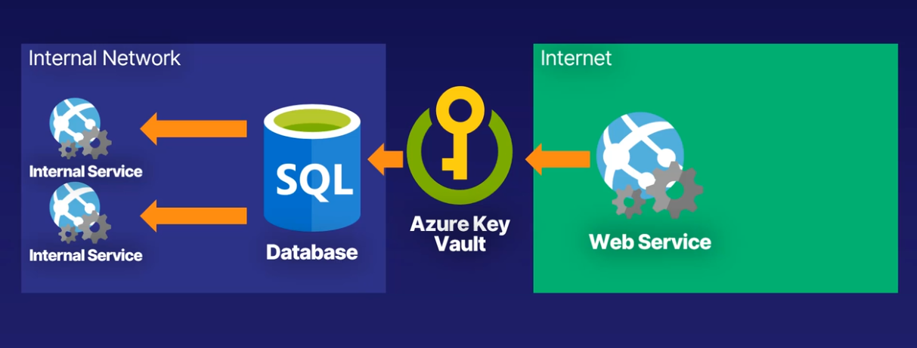

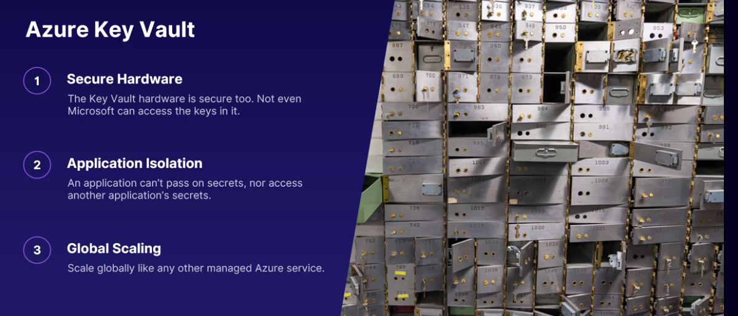

Azure Information Protection

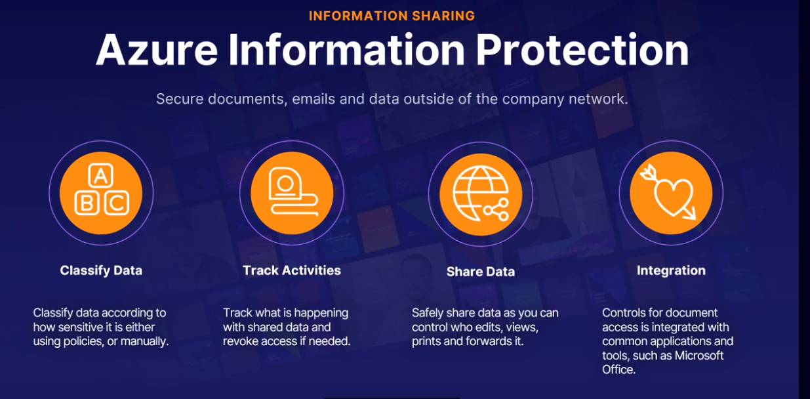

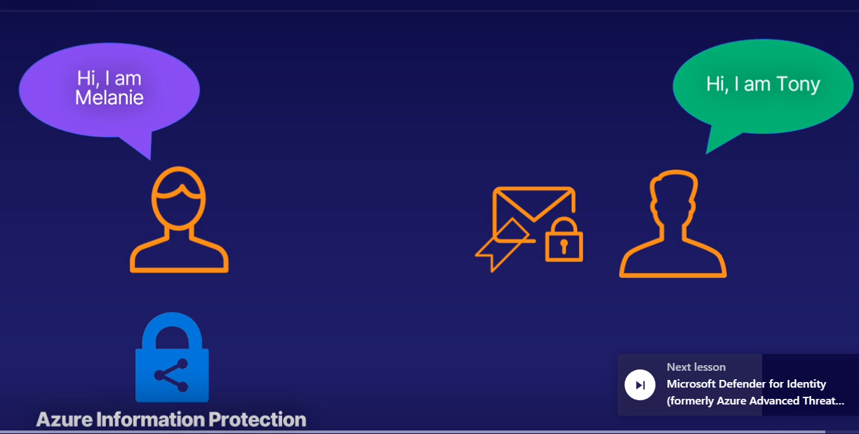

Microsoft Defender for Identity

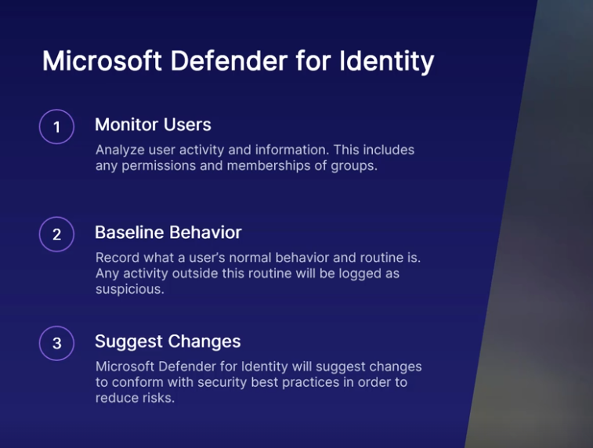

Microsoft Defender for Identity helps you monitor users in your on-premises environment and their behavior. Microsoft Defender for Identity analyzes user activity and information across your network, including permissions and membership for each user.

Cyber attack kill chain. That is, the ways that attackers get into your systems.

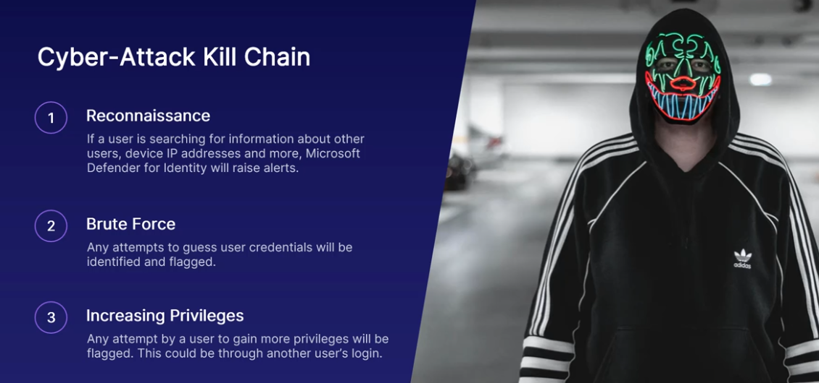

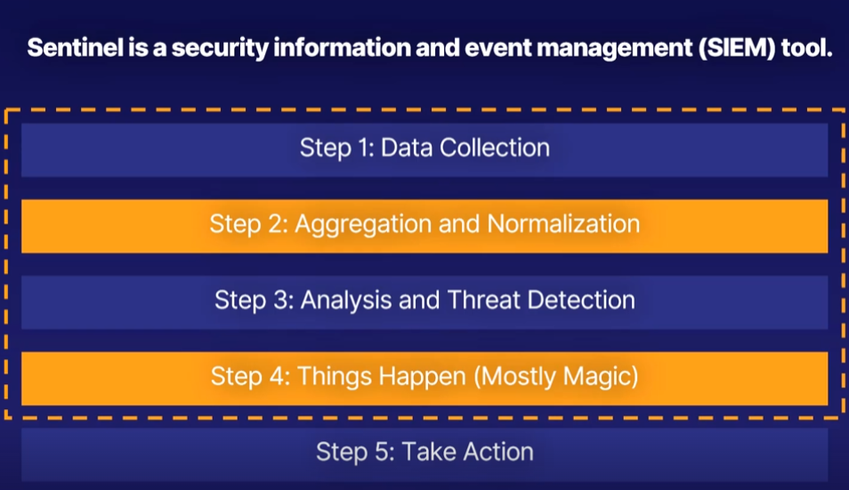

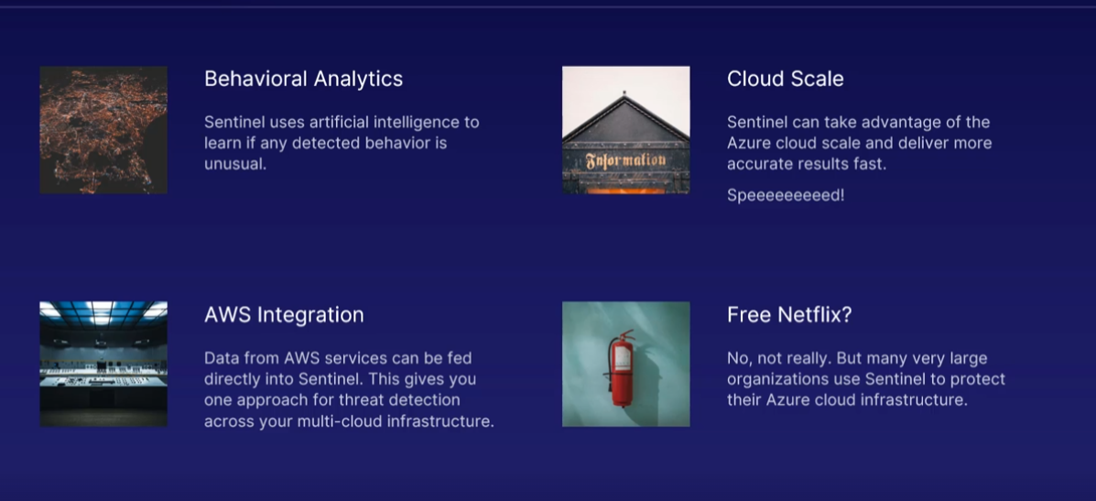

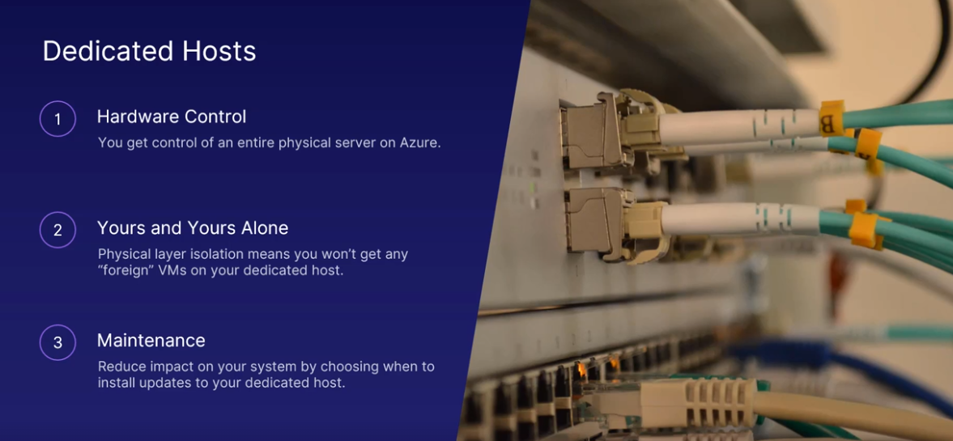

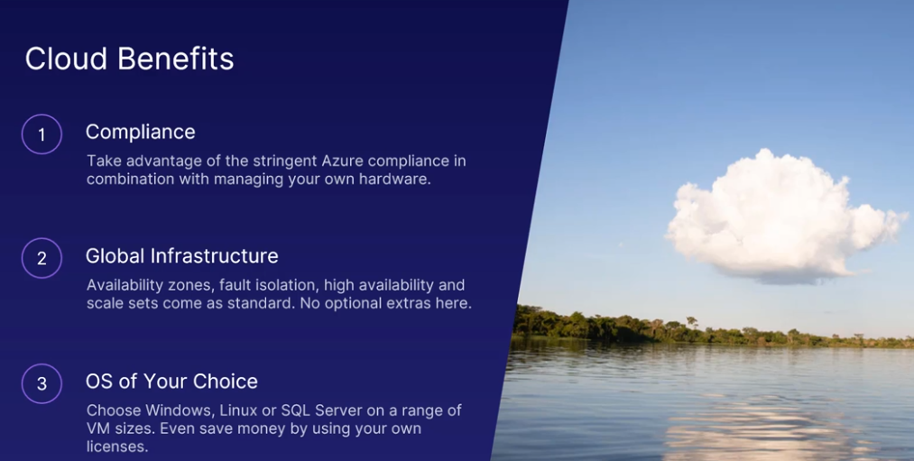

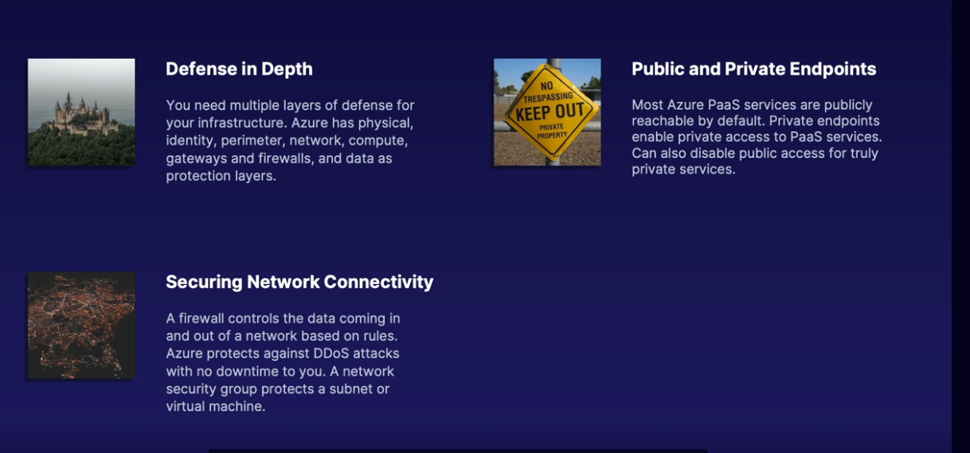

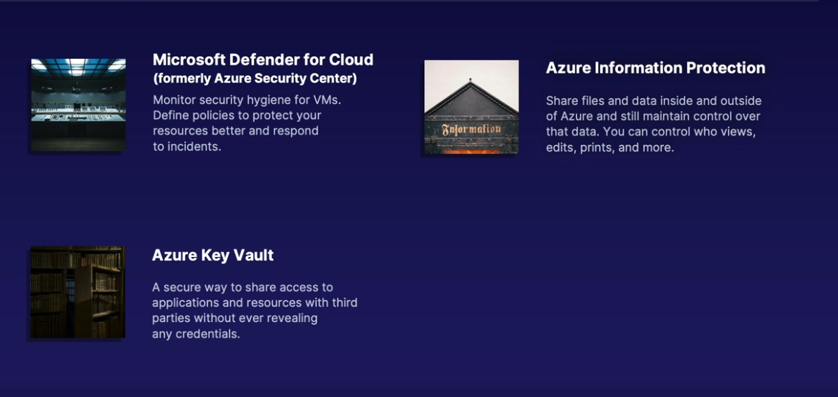

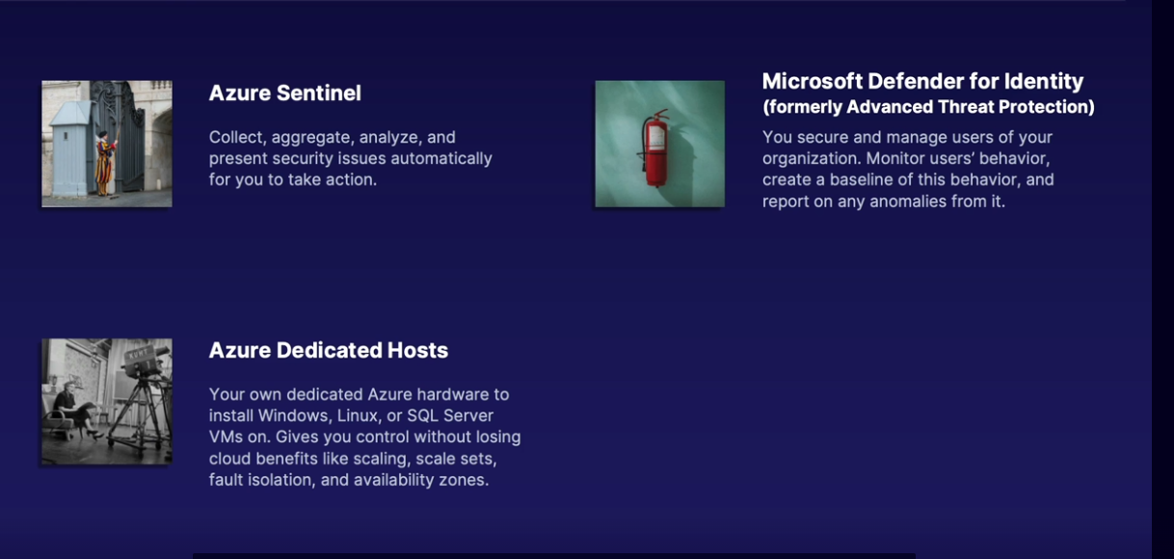

1.There is a potential threat to your Azure infrastructure from an outside attacker. Which service is best for detecting the threat?

* Microsoft Sentinel
* Defense in Depth
* Azure Security Center
* Key Vault

Microsoft Sentinel will collate, aggregate, and analyze data from multiple Azure services to detect any unusual behavior or patterns. You can then take action on the information.

2.What does Microsoft Defender for Identity (formerly Azure Advanced Threat Protection, also known as Azure ATP) do?

* Finds vulnerabilities in the data passed to an Azure service in your subscription
* Protects your privacy when sharing access to Azure resources with third parties
* Helps you monitor user behavior in your on-premises and cloud environments
* Helps an organization to classify and (optionally) protect its documents and emails by applying labels

Microsoft Defender for Identity helps you detect and investigate security incidents across your Azure accounts, both on-premises and in the cloud. It monitors users, devices, and resources in terms of their behavior. If any behavior is out of the ordinary, an alarm can be raised.

3. What is a distributed denial-of-service attack?

* An attack carried out from multiple Azure datacenters
* An attack where lots of computers target a single server or website with the aim of making it stop
* An attack meant to target multiple services and bring them to a stop
* An attack that is partly generated by cloud services and partly by on-premises servers

A distributed denial-of-service (DDoS) attack comes from a large number of sources with the sole aim of stopping your service. This is done through sending web traffic to your service until it can't handle it all and stops working. Azure has tools to protect against DDoS attacks, which sometimes aren't attacks at all but just increased visitor interest in services or content.

4. If you don't want to share the hardware your VMs run on, how can you manage that in Azure?

* Use Azure Security Center to create a private zone for your VM cluster.
* Secure the network connection to your VM using a network security group.
* Use Azure Dedicated Host.
* Use Premium tier virtual machines.

Azure dedicated hosts run on their own dedicated hardware inside the Azure datacenter and only your chosen VMs will run on it.

5. Which statements are TRUE about Azure Key Vault?

* You can share a password with a third party to use, without ever revealing the password itself.
* A third-party app can pass access to a secret to another third-party app, if authorized in the Azure portal.
* Access to secrets and passwords can be granted or denied very fast and as needed.
* Azure Key Vault defines security policies for Azure services.
* Azure Key Vault removes the need for passwords in your services.

Azure Key Vault is a secure place to store passwords and other secrets. Once stored, you can never retrieve the actual value or keys, but you can share access to the value or specific versions of a secret with other third-party clients and other Azure services. You can also restrict or deny access easily and quickly, should it be necessary.

6. What is the main function of Azure Information Protection?

* To protect your privacy when sharing access to Azure resources with third parties
* To find vulnerabilities in the data passed to an Azure service in your subscription
* To help an organization classify and (optionally) protect its documents and emails by applying labels
* To make sure attackers can't get to the Azure services in your subscription

Azure Information Protection helps secure email, documents, and sensitive data inside and outside your company walls. You can classify sensitive data, track activities on shared files and documents, collaborate securely, and much more. There is no active security service included, such as scanning the files being protected.

7. What is the purpose of having defense in depth?

* To use machine learning models to improve the defense measures of your Azure infrastructure
* To ensure multi-cloud strategies don't compromise the Azure infrastructure
* To provide several layers of defense for your resources, data, and assets
* To use multiple Azure regions for failover protection in case of service outages

The defense-in-depth concept stipulates that you need more than just one security measure for your data and resources, such as firewalls, network gateways, and physical measures.